PCB Showcasing

The project showcases the internal PCBs of CRO, Function Generator, Power Supply Unit and a Wi-Fi router. By displaying the circuitry behind, the project facilitates a deeper understanding of hardware architecture and component integration.

1.CRO (Cathode Ray Oscilloscope)
The Cathode Ray Oscilloscope (CRO) is an essential electronic instrument used in physics and engineering labs to observe and analyze electrical signals. It provides a visual representation of voltage waveforms over time, allowing users to measure, monitor, and understand the behavior of electrical signals.

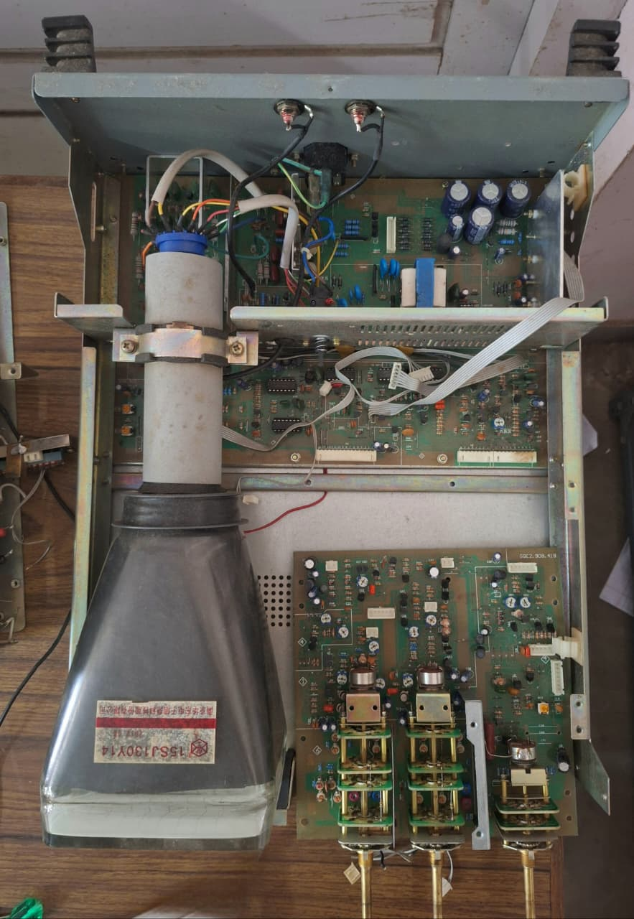

2.Function Generator
A function generator is an electronic test instrument that creates various electrical waveforms (like sine, square, triangle, sawtooth) across a wide frequency range, allowing users to test, analyze, and troubleshoot electronic circuits and systems by providing signals with precisely adjustable parameters such as peak-to-peak voltage, DC bias etc.

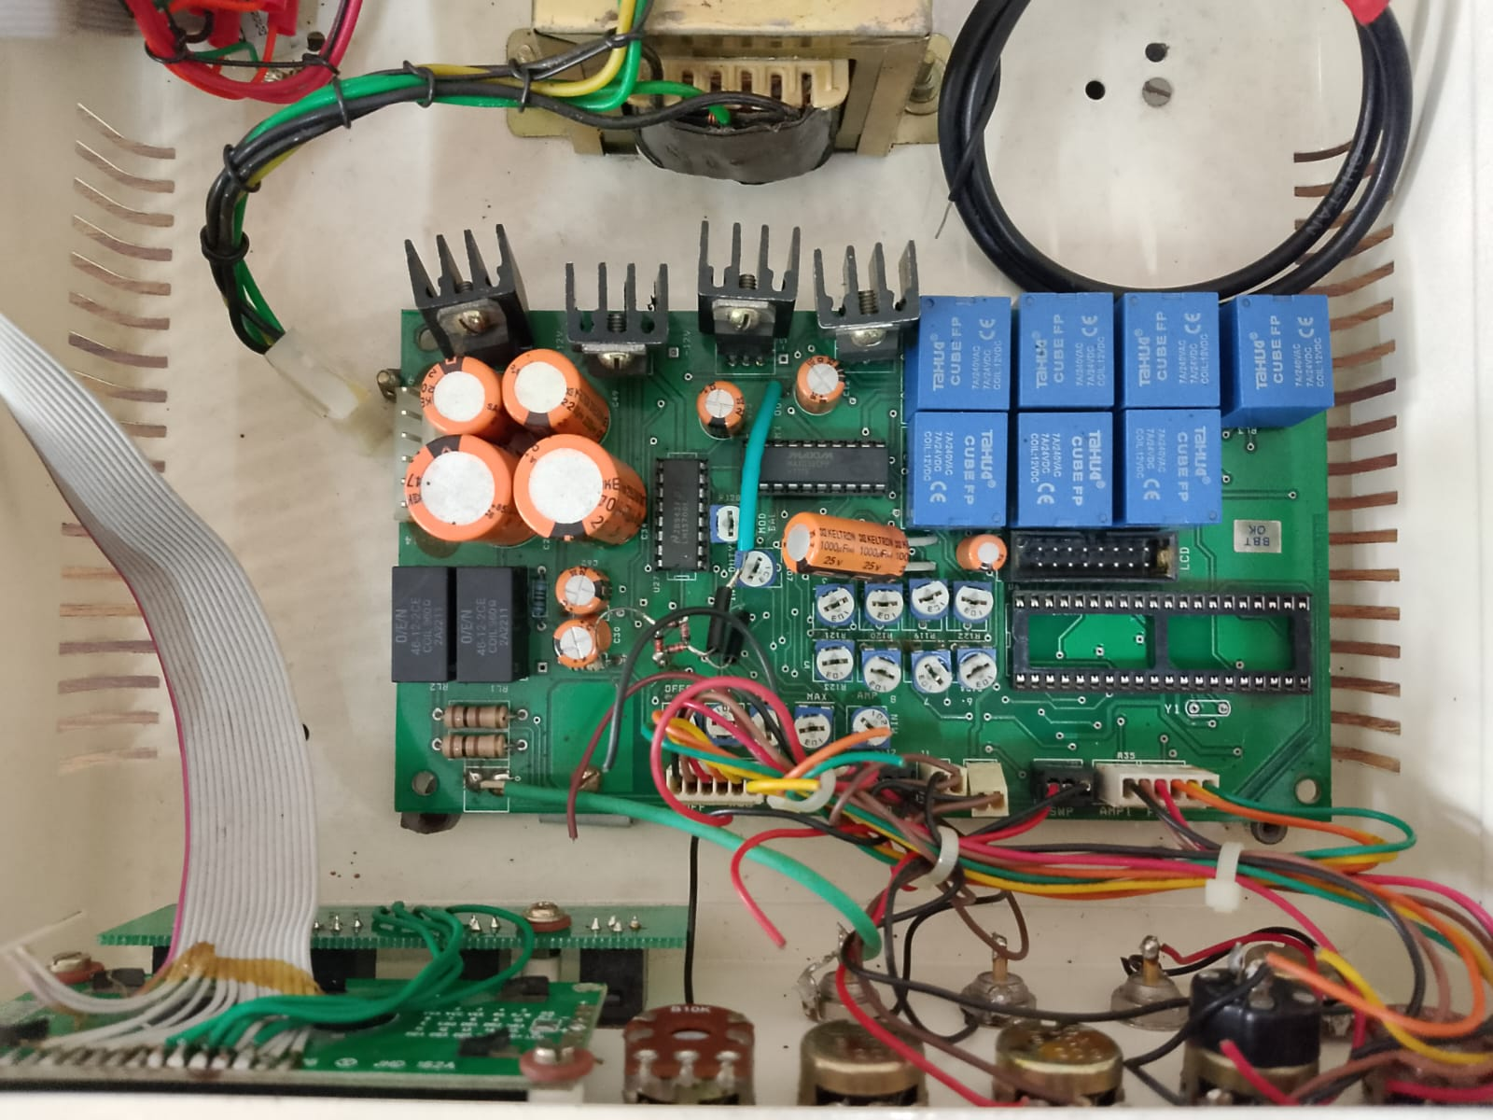

3.Power Supply Unit
A regulated power supply unit is an electronic circuit that converts unregulated alternating current (AC) into a constant, stable direct current (DC) output, regardless of changes in input voltage or load current. It ensures a fixed, ripple-free voltage necessary for sensitive electronics like computers, lab equipments etc.

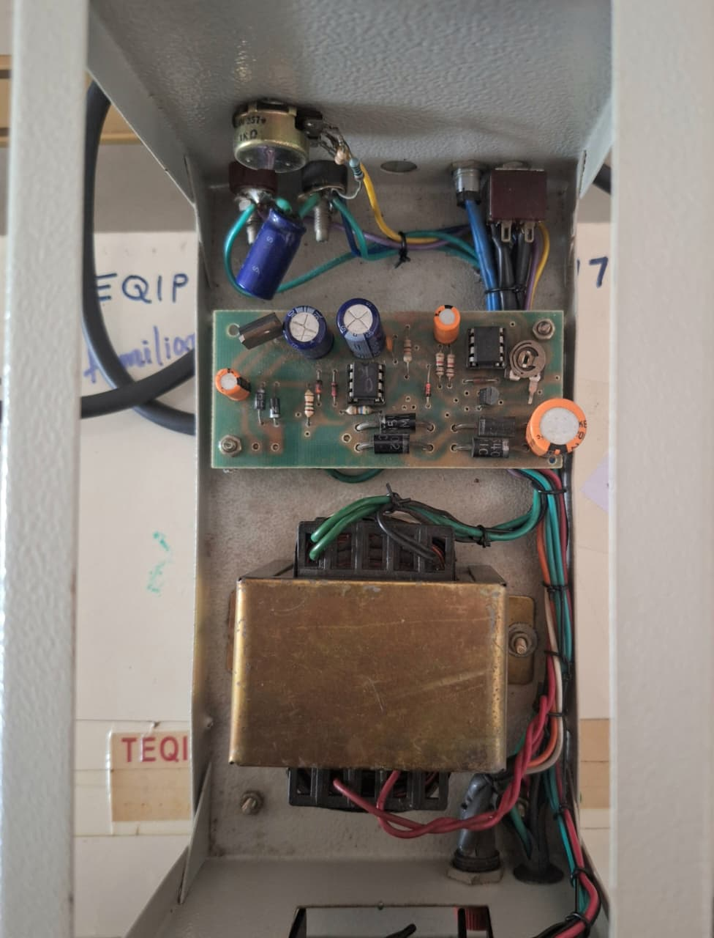

4. Router Box
A router box is a networking device that acts as a central hub, connecting multiple devices (computers, phones, TVs) to the internet and to each other, often providing Wi-Fi.It creates a local area network (LAN) and manages traffic between it and the wide area network (Internet).
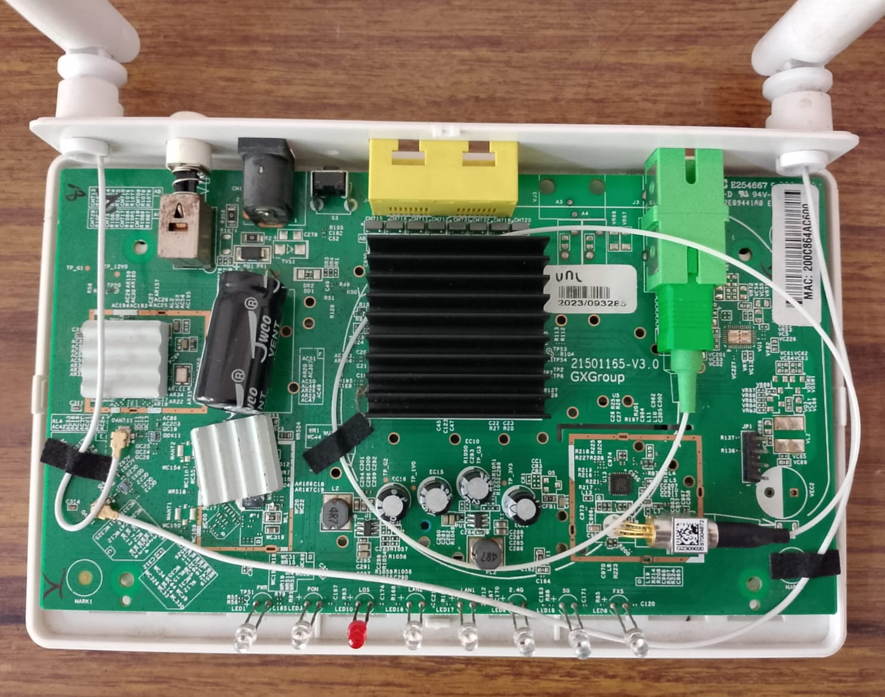

Student Details
1. Muhammed Jazil
2. Roshna Palatty Santhosh
3. Vandhana S
4. Midhun Shankar

